Initial ANSYS simulation results for the thigh

Material: 6065-T5 Aluminum

Length: 12 inches (6 inch per section)

Thickness: ½ inch

Width: 1 inch

Hip Piston Force: 550 N

Knee Piston Force: 76 N

Hip Force: 18 N

Knee Force: -9N

Maximum Structural Error: 0.0028

Next:

* Calculating maximum dynamic forces and inserting them into the model
* Buckling analysis on each straight section of the thigh

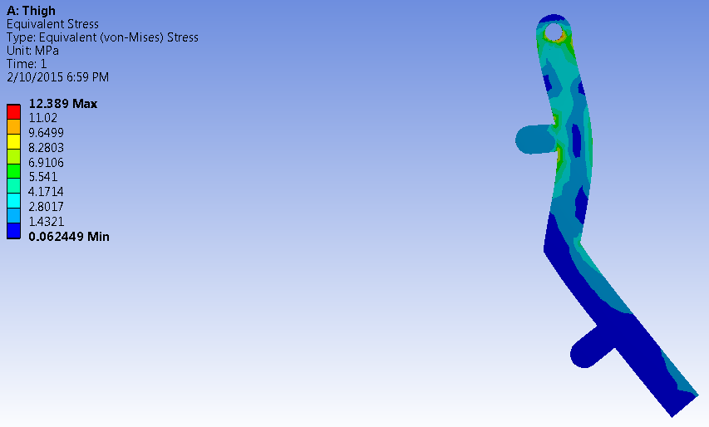

Figure Initial Equivalent Stress results using static joint forces and dynamic piston forces for a creep gait

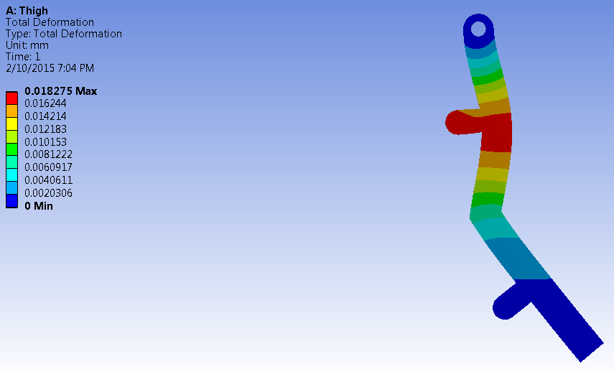

Figure Total deformation of the thigh in mm